To upload the Manhattan message files to churchnyc.org web site

1. On your computer, rename your message (mp3), document, or any other files to yyyymmdd_Manhattan_….. format. (The website displays the files by their filename order.)

e.g. 20151004_Manhattan_special_fellowship.mp3

We can take mp3, mp4, .txt, .doc, .pdf … files.

2. Goto the file upload web site:

<http://churchnyc.org/upload/uploader_Msg_Manhattan.asp?cnyc_user=skim>

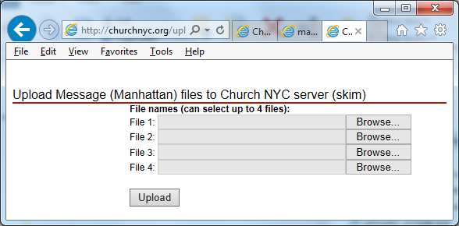

Click the File 1’s “Choose File” button, to select your lesson file from your workstation/computer

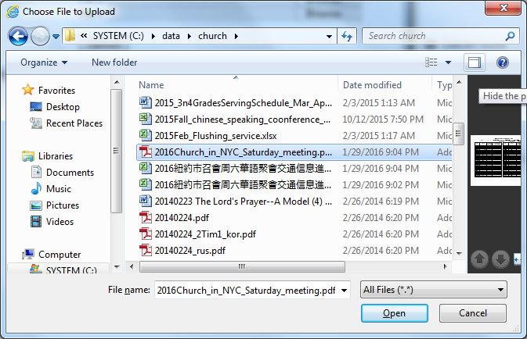

Select your file and click OPEN button

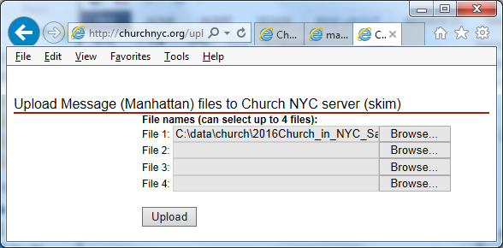

If you have more files to upload, click file 2 “choose file”, same to file 3 and file 4.

Click the “Upload” button,

It seems nothing happens, please just wait, it might take about 5 to 10 minutes to upload a 30 MB doc file.

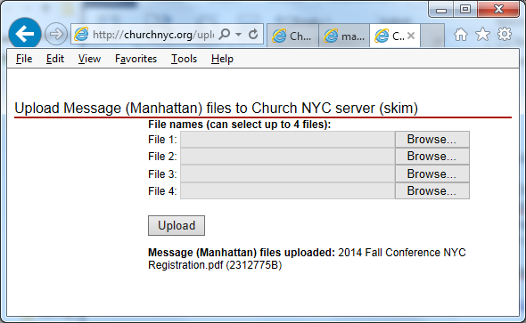

When it is done, a message will be shown under the upload button.

3. You cannot delete the uploaded files, but you can over write them by upload the files again.

Contact brother Tony Shu ([shu.tony@gmail.com](mailto:shu.tony@gmail.com) or 917-923-0994) if you want to delete files or have technical issues.

4. To check your uploaded files,

Goto churchnyc.org web site, click “Message” then click “Manhattan”

